Automatic Measurement System for Cargo Volume

Sponsor: Panasonic

Mentor: Zhuosi Zhang

Instructor: Mingjian Li

Group members:

Xinyi Wu, wu.xinyi@sjtu.edu.cn

Zesen Wang, UncleSam@sjtu.edu.cn

Yetong Zhang, yetong@umich.edu

Yier Zhang, yier_0227@sjtu.edu.cn

Zitao Zhang, crazybullet28@sjtu.edu.cn

**Abstract**

With the rapidly growing needs of cargo delivery in China, it is necessary to develop an automatic system that can efficiently measure the volume of goods during the packing and loading process of cargo transportation. To restore the environment in delivery company, the goods we will be measuring will be on a conveyor belt, and our system is supposed to return the volume and shape of the goods automatically. In order to be competitive with existing products for measuring cargo volumes, to make the system accurate, time efficient, and cost saving is the requirement of our customer, and therefore the objective of our project.

After analysis on the customer requirements, we think depth cameras are suitable for our project. They can accurately return the distance of points in the range of several meters, and the cost is lower than the systems using laser measurers. We will also use camera supports and light reflection tape in aid with the depth cameras. The engineering specifications should include speed of conveyor belt, number of depth cameras, filming angle difference, camera distance, cargo size range, max unilateral error, processing time, and cost restriction. Among all these engineering specifications, the most important one is the “cargo size range”.

As for the project plan, we have done our project concept generation and selection by design review 1. We plan to buy all the materials needed and develop a workable prototype by design review 2. After that, we will improve the algorithms, deal with 3D model output, and do evaluation on the performance of our project. By the time of design expo, we are supposed to finish the final version of our prototype, and develop the application for demonstration.

**1. Problem Description & Introduction**

Our project aims at improving the efficiency of the packing and loading process during cargo delivery. The motivation of our project is the quickly growing demand of cargo delivery in China. The packing and loading process is an important part of cargo delivery. Due to limited capacity of transportation tools, how to take good use of the full capacity of transportation tools directly impacts the delivery speed. And this calls for the accurate measurement of the volume of the goods. The primitive way to measure the volume of goods is manual measurement, which is slow in speed, error-prone, and have problems in special-shaped measurement. A better way is to use laser technology, but the cost is too high.

* + Our objective is to develop a low-cost system that can automatically measure the volume and shape of goods on a conveyor belt. The hardware we will use are two Kinect depth cameras. The cameras will be placed in two different positions and take pictures of the goods on the conveyor belt. We will use algorithms to integrate information from both cameras and reconstruct the shape of the goods in computer. The volume of the goods will be calculated, and a three-dimensional model map will be built.

**2. Competitive & related products and technology**

KinectFusion Algorithm [1]:

The main idea of KinectFusion Algorithm, as shown in Figure 1, is to allow user to reconstruct a 3D scene in real-time by moving the Kinect camera around the real scene. At every frame, it uses the built-in function to generate a point cloud according to the depth figure. Then, to align and combine the current point cloud and the previous one, it uses Iterative Closest Point (ICP) [3] to find the best transformation. At the last step, it uses the greedy triangle algorithm to reconstruct the surfaces according to the point cloud.

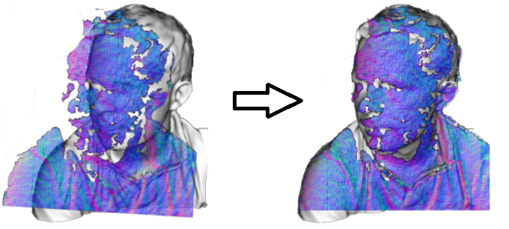

Figure 1: Demonstration of KinectFusion Algorithm [1].

The drawback of the algorithm is that it requires large computation capacity (GPU, Nvidia GTX480 in an open source implementation [4]) to obtain the real-time construction. Also, the algorithm does not fit our problem because it does not filter out the background and, in our problem, the object is moving while the Kinect sensors are fixed.

Optical system for detecting three-dimensional shape[5]:

The system is designed to move a parallel beam of light in the direction normal to the object, reflect the beam by a mirror at a predetermined inclination angle, and produce an image of the object by the image forming lens, which converges the reflection beam to a point.

Though the system could produce a 3D shape of cargoes, it requires the measured cargo to be still. Therefore, the setting of a moving conveyor belt makes the system undesirable in our case.

Video-based shape detection apparatus[6]:

This is an apparatus patented by Panasonic, the sponsor of our project. The apparatus records the process of a object passing through by video, which could be considered as a consecutive sets of images collected at a relatively high frequency. The edges are identified according to changes in neighbouring images, calculated by the derivative. Further, the shape is then reconstructed by edges.

The apparatus manages to deal with moving cargoes. However, the high memory cost of and high computational requirements for taking videos for each cargo remain to be improved.

Autofocusing and image detection at each focus level[7]:

The key idea is to use the distances from points on the object to the camera. In order to get the distances, the system picks up a plurality of images of objects at different focus levels having different Z-axis coordinate values correspondingly, and then detects maximum focus measure values in pixels.

This system also requires the stillness of the cargo. Moreover, it is inefficient in taking a plurality of images and analyzing each of them.

**3. Customer Requirements and Engineering Specifications**

Our customer requires our project design to have a high measurement efficiency, manpower saving, low cost and standardized measurement process. For the measurement setting, it should be easy to build and install, easy to use, able to handle with different size and special shape cargos. For the measurement results, it should be accuracy enough and can be visualized to the user.

Customer requirements:

1. High efficiency
2. Save manpower
3. Low cost
4. Standardize the measurement process
5. Easy to build and install
6. Easy to use
7. High accuracy
8. Different cargo size capacity
9. Special-shape cargo measurement
10. Visualization output

From these given requirements, we generate engineering specifications by the following process:

First we need to define the background setting, which includes the speed of conveyor belt, the cargo size range, and the estimation of processing time. These properties are related with the efficiency of measurement. So we need to simulate a circumstance of the usage of our project, such as long assembly line operations and packing. Under this kind of situation, the cargo size should be within the range of 10*10*10 cm^3 to 40*40*40 cm^3.

For the speed of conveyor belt, we initially restricted the speed within 0.2-0.5 m/s, because it is the most common speed of conveyor belts of our size. After several groups of experiments, we find out that when the speed is at 0.4m/s

did several group of experiments

For the processing time, we assume that the distance of 2 cargos is 2 meters. Then it needs 4 seconds for the cargo completely pass the view of camera and the second cargo be sent to the position (for the speed of 0.5m/s). So we should limit the processing time within 4 seconds.

Then we need to decide the design details. For numbers of camera, because we need to handle with special size cargos, 2 depth cameras are necessary to film at different angles to get a more detailed cargo shape. Considering the cost limitation and the accuracy requirement, we don’t need to have more depth camera. For the position and filming angle, we decide to place the camera at both sides of the conveyor belt. Since the camera has 43° vertical by 57° horizontal field of view[9], we need to put them at a distance about the same as the maximum length of the object to catch the whole object. To capture the front or rear side, we need even longer distance. So the distance we put our camera is between 1 meter to 1.5 meters. Also, enable to make a clear reference points on the conveyor belt, the filming angle range shouldn’t be set too large. -45 deg. to 45 deg. should be a good choice.

As for the maximum unilateral error, we searched for some articles. It is found that errors increase quadratically from a few millimeters at 0.5 m distance to about 4 cm at the maximum  
range of the sensor which is about 6 meters. [10] We also checked the report of two other groups of people that used depth camera to measure volume, and their percentage errors for volume are between 0.1% to 16%. [11][12] Consider the object they measure are smaller than ours, and their distance of camera is smaller than ours, we estimate our unilateral error to be no larger than 10%.

Our cost will consist of three parts: Kinect cameras, camera support, light reflective tape. The cost for conveyor belts and computing tools (computers) will not be taken into account since they are considered to be off the shelf. The cost for two Kinect cameras is 1488*2 = 2976RMB. The camera support is about 30*2 = 60RMB. The cost of light reflection tape is about 10RMB per meter of the conveyor belt. So in total, the cost is about 3500RMB (suppose the target conveyor belt has the length of 20 meters).

In summary, the engineering specifications are:

1. Speed of conveyor belt (0.4m/s)
2. Cargo size range (10*10*10 cm^3 ~ 40*40*40 cm^3)
3. Processing time (4s)
4. Number of depth cameras (2)
5. Filming angle range(-60 deg. ~ 60 deg.)
6. Camera distance (1m ~ 1.5m)
7. Max unilateral error (10%)
8. Cost restriction (3500RMB)

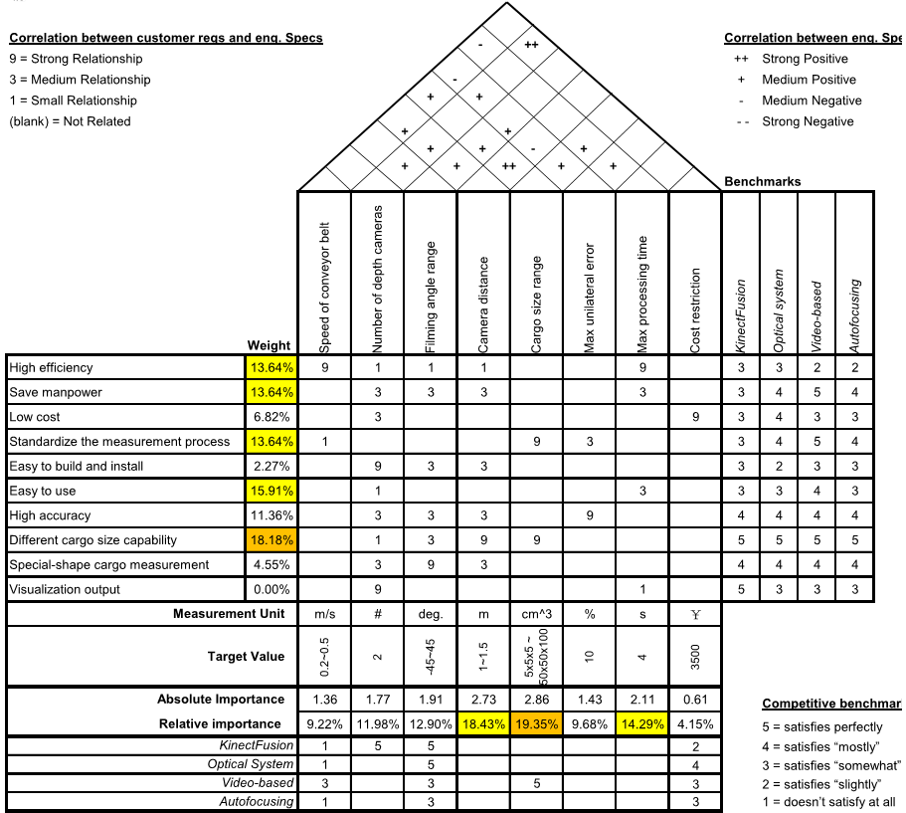

Figure 2: QDF.

Our QFD is shown in Figure 2. Among all the customer requirements, the most important one is “different cargo size capacity”, then follows “easy to use”, and then “high efficiency”, “save manpower”, and “standardize the measurement process”. Because the usage of our project is likely to be in long assembly line operations and packing, so it’s very important to ensure that our design can measure the cargo volume with various size.

Among all the engineering specifications, the most important one is the “cargo size range”, then follows the “camera distance” and the “max processing time”. The first 2 are both correlated to the CR of “different cargo size capacity”, so they both have high weights. And the “max processing time” is correlated with “high efficiency”, “save manpower”, and “easy to use”.

We need to always focus our attention on these high-weight specification during our project design to make sure that the customer requirements can be fulfilled.



**4. Project Plan**

Figure 3 shows the schedule for our project in Gantt Chart. There are four milestones marked in red: Design Review 1, Design Review 2, Design Review 3, and EXPO. We have arranged our schedule into 5 parts: the first part is background research, and the other four parts correspond to the four milestones.

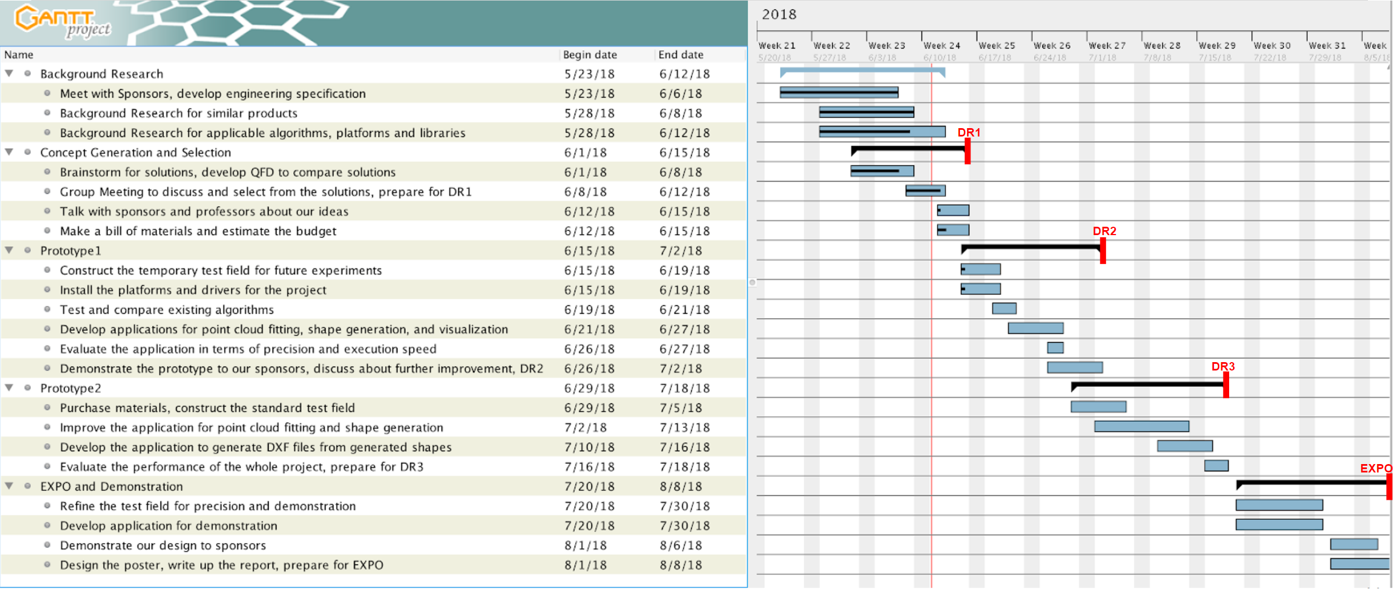

Figure 3: Project Schedule.

**5. Conclusions**

To conclude, our project is to fulfill the requirements of our client, Panasonic, to build an automatic system to measure the volume of cargoes on a conveyor belt. The system is required to have high efficiency and accuracy, standardized measurement process, easy accessibility to build, install and use, high compatibility to measure cargo of different sizes and various shapes, and preferably visualized output. Among those, the most important two are compatibility and accessibility.

We translated the requirements into engineering specifications. As a result, the main hardware we are going to use are two kinect 2.0 depth cameras, and mechanical structures to support the cameras. In comparison with existing products in the market, our system requires fewer hardware supports, and thus cuts down the cost. Meanwhile, we restrict the unilateral error of our volume measurement to be under 10%, an acceptable value for our customer, to assure the accuracy. Therefore, we are confident to exhibit a solid design and further build a promising product.

**6. References**

[1] Newcombe, Richard A., et al. "KinectFusion: Real-time dense surface mapping and tracking." *Mixed and augmented reality (ISMAR)*, 2011 10th IEEE international symposium on. IEEE, 2011.

[2] J. Loera, J. Rambau and F. Santos (2010), *Triangulations: Structures and Algorithms* (2nd revised ed.), Springer-Verlag, ISBN 9783642129711 Chapter 3: Polygon Triangulation: pp.103.

[3] Besl, Paul J.; N.D. McKay (1992). "A Method for Registration of 3-D Shapes". *IEEE Trans. on Pattern Analysis and Machine Intelligence*. Los Alamitos, CA, USA: IEEE Computer Society. 14 (2): 239–256. doi:10.1109/34.121791

[4] Pirovano, Michele. "Kinfu–an open source implementation of Kinect Fusion+ case study: implementing a 3D scanner with PCL." no. October 2012 (2011).

[5] Kakinoki, Yoshikazu, Masato Nakashima, Tetsuo Koezuka, Noriyuki Hiraoka, Hiroyuki Tsukahara, Yoshinori Suto, Yoshitaka Oshima, and Shinji Hashinami. Optical System for Detecting Three-dimensional Shape. Fujitsu Ltd, assignee. Patent US5004929A. 2 Apr. 1991. Print.

[6] Itsuzaki, YasuoYoshihiro, Masatoshi Nakamura, Noriyuki Suzuki, Misuzu Takano, and Kinji Horikami. Shape Detection Apparatus. Panasonic Corp, assignee. Patent US5995663A. 30 Nov. 1999. Print.

[7] Nakagawa, Yasuo, and Shree Nayer. Method of Detecting Solid Shape of Object with Autofocusing and Image Detection at Each Focus Level. Hitachi Ltd, assignee. Patent US5151609A. 29 Sept. 1992. Print.

[8]. Specification for “Heavy Duty Slider Bed Conveyor - Model TL 42" OAW, 17'-1" long”,

Hytrol Conveyor Company, Inc. http://www.cisco-eagle.com/catalog/product/12410/

heavy-duty- slider-bed-conveyor-model-tl-42-oaw-17-1-long

[9]. “Kinect for Windows Sensor Components and Specifications” https://msdn.microsoft.com/en-us/library/jj131033.aspx

[10]. K. Khoshelham, S.O. Elberink, “Accuracy and resolution of Kinect depth data for indoor mapping applications”, Sensors, 12:1437–1454, 2012.

[11]. Li, Lingling, Z. Wang, L. Qing, and H. He, “Fast Volume measurement based on Kinect 2.0 depth image”, *Microcomputer & Its Applications,* vol. 1, no. 7, 2017, pp. 35-38.

[12]. Dellen, Babette, I. Rojas, “Volume measurement with a consumer depth camera based on

structured infrared light”, 16th Catalan Conference on Artificial Intelligence, poster session, 2013, Vic, Spain, pp. 1-10, ACIA.

**7. Bios**

Zesen Wang:

I’m an undergraduate student at University of Michigan - Shanghai Jiao Tong University Joint Institute majoring in electrical and computer engineering. Also, I joined the 3+2 program with Royal Institute of Technology majoring in machine learning, so I’m also a graduate student at KTH.   
In the next year, I’m going to finish my courses at KTH and to work on the master thesis. I joined some industrial field trips to companies like Spotify, and I learned about some application of knowledge in machine learning in practical projects in companies. Visiting real workplace and listening to stuff there really inspire me of how to develop my skill set in the future. In the next two years, except for the courses given by the university, I plan to learn some practical skills that help me to work on large projects like techniques on mass data storage and distributed computation setup which does not come up in the courses I learn because in the university courses, students always work on simplified demos instead of real products. I hope the capstone design and the master thesis in next year can give me more experience on working on real products.

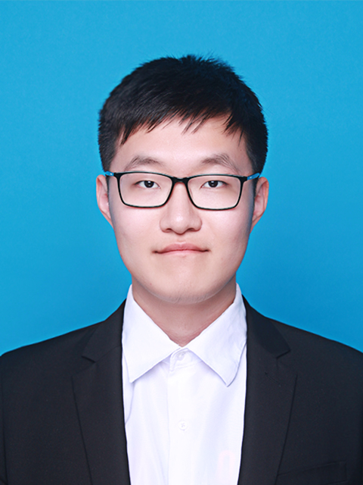

Zitao Zhang

I'm Zitao Zhang, a senior ECE student. I'm interested in computer science, so I would like to work in a relative field in the future. I've worked as an internship in eBay Shanghai last year, which gives me a lot of working experience, such as how to cooperate with other group members in a same developing project. And it also let me realize that I still need further learning to expand my skills and knowledge. So I attended the 3+2 program, studied at KTH Royal Institute of Technology as a master student in the passing semester. My major is Machine Learning, which is a very popular field recent year. It is a quite cool subject. I've learned a lot about AI and deep leaning. This technology can be used in a wide range, such as image classification, voice recognition, and model designing.

I haven't decided yet about whether I would go to work or apply for a Ph.D. after finishing my master degree. The machine learning is a very hot field, so it might not be too difficult for seeking a job in this field. But if I want to work in a good position in a good company in future, only a master degree seems not enough. Another problem is that it could be very difficult for applying a Ph.D. in machine learning or AI because of the intensive competition. Maybe I need to collect more information during the second-year study in KTH, to decide which way would be more suitable for me.

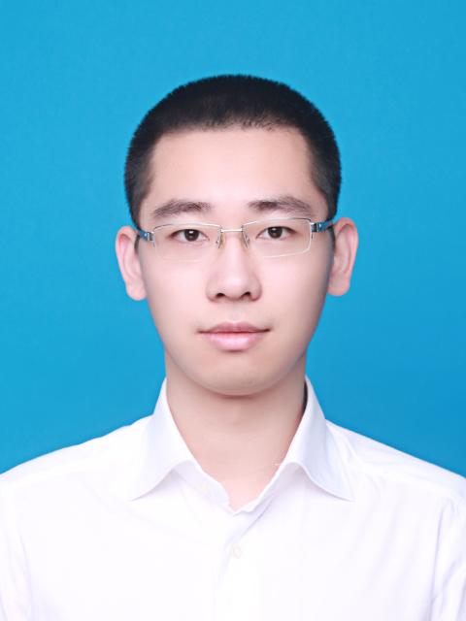

Yier Zhang:

I’m Yier Zhang, senior student at the University of Michigan, Shanghai Jiao Tong University Joint Institute. My major at JI is Electrical and Computer Engineering, and major at UM is Electrical Engineering. Courses I’ve taken include VLSI design, computer architecture, embedded systems and control systems design. I’m interested in embedded systems and design, and I enjoy building something fancy. During my embedded systems design course, my teammate and I built a drawing robot that mimics human’s writing on a resistive touch screen. I also have some experience in machine learning, I collaborated with another student to write a few learning programs such as the “Pong” game, where a pad is controlled to rebound a ball and break as many bricks as possible. I think the “AI rush” will keep for a long time, so as a new comer I need to gain more experience in this field. I have an internship experience in company, and I quite enjoyed the atmosphere working in a small team. After this semester, I will go to America for graduate study in ECE. I hope after my graduation, I can join the industry and develop a product of my own.

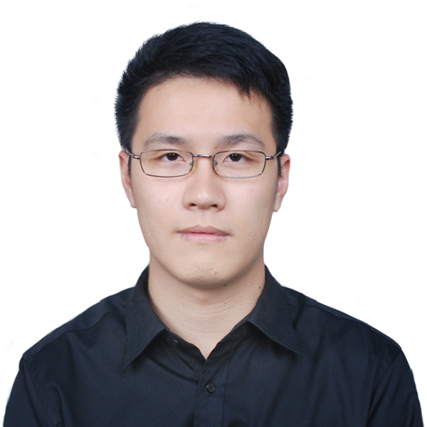

Yetong Zhang:

I’m Yetong Zhang, a senior student from UM - SJTU Joint Institute. I have received the bachelor's degree in computer engineering at University of Michigan, and I’m now pursuing degree in mechanical engineering at Shanghai Jiao Tong University. I am interested in robotics, and I will go to Georgia Tech for PhD with a focus on the intersection field of robotics and reinforcement learning. From my interdisciplinary education background, I have gained rich experience in mechanical design, system control, computer vision and artificial intelligence. During my internship at DJI, I joined a research team in developing computer vision detection algorithms using deep learning methods. This is also my first project to learn about the product design process, and understand the robotics industry. I have also got research experience from Structural Dynamics Lab, Autonomous Robotic Manipulation Lab, and Vision and Learning Lab during my study at University of Michigan. In the future, I hope to increase the intelligence of robotics with smarter algorithms, so that they can better facilitate people’s daily life. In addition, I am also a tourism enthusiast, an old driver, a good table tennis player, and a handsome single man.

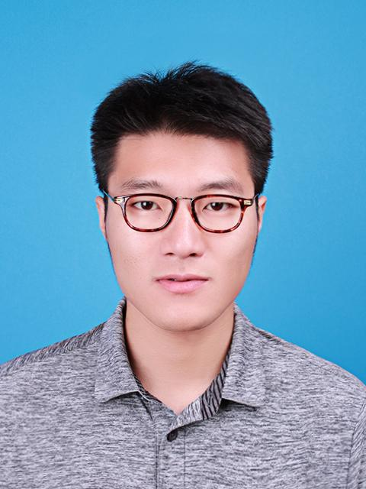

Xinyi Wu:

I am Xinyi Wu, majoring in Electrical and Computer Engineering at the joint institute and Data Science at the University of Michigan. My research interest is natural language processing, specifically, to understand expressions and underlying information using data mining and machine learning techniques combined with linguistics insight. The ultimate goal is to break the boundaries of communication across knowledge and cultures.

In order to sharpen my skills in this field, I actively participated in research and internship. Under the instruction of Professor Rada Mihalcea, director of UM AI Lab, I developed a system to automatically understand and evaluate the motivational interviewing. Besides, I analyzed disparities of Twitter interaction of people in different relationships in order to build online social network. Moreover, I built a multi-product pricing system at JD.com, and improved a map-matching algorithm at UM Transportation Research Institute. Later, I will attend the University of Washington for a master’s degree to further enhance my knowledge and research abilities.

